<https://github.com/ayswarjya009/TCS-Edureka-NodeJS-Ayswarjya.git>

Please refer question1 folder

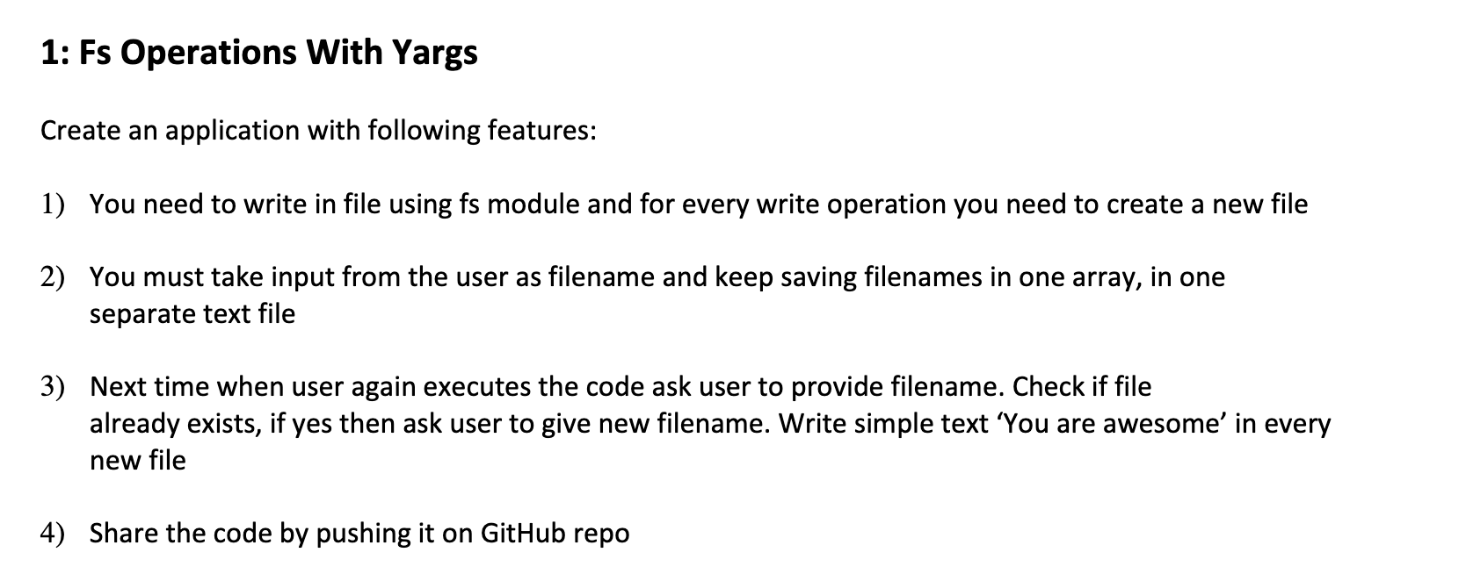

Please refer question2 folder

